**LAB MANUAL**

**Name:** Muhammad Bilal Asif

**SAP ID:** 70133498

**SUBJECT:** Web Development

**INSTRUCTOR:** Sir Amish Hassan

**Lab 2**

**Ex#1**

<!DOCTYPE html>

<html>

<head>

<title>My first Web Page</title>

</head>

<body bgcolor="green">

<font size="16" color="white" face="Arial">Welcome to AITS, TIRUPATI...</font>

</body>

</html>

**Output**



**Ex#2**

<!DOCTYPE html>

<html>

<head>

<title>program 3</title>

</head>

<body>

<center>

<h1>Basic web design Lab</h1>

</center>

<h2 align="left"> Defination</h2>

<h3 align="left"> Website</h3>

<h4> heading 4</h4>

<h5> heading 5</h5>

<h6> heading 6</h6>

<p>

A set of inter connected web pages usually including a home page and many

other web pages

</p>

</body>

</html>

**Output**

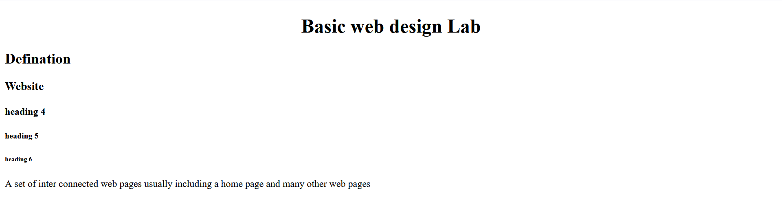

**Ex#3**

<!DOCTYPE html>

<html>

<head>

<title>program 09</title>

</head>

<body bgcolor="pink">

<font color="red"><marquee direction="left">Welcome to AITS TIRUPATI</marquee></font>

</body>

</html>

**Output**



**Lab 3**

**Ex#1**

**HTML**

<!DOCTYPE html>

<html>

<head>

<title>Get the country capital</title>

<link href="lab3.css" type="text/css" rel="stylesheet"/>

</head>

<body>

<img src="web-designing\Lab Manual\istockphoto-1419410282-1024x1024.jpg" alt="">

<div class="form-box">

<font color="white" size="4"><b>Select the country name to find its capital and

continent</b></font><br/><br/>

<br>

<select <input type="text" class="resizedTextbox" id="myedit"/>>

<option>Select Country</option>

<option>Germany</option>

<option>United States of America</option>

<option>India</option>

<option>United Kingdom</option>

<option>France</option>

</select>

</div>

<div id="result">&nbsp;</div>

</body>

</html>

**CSS**

h1{

text-align:center;

}

body{

background:

url("web-designing\Lab Manual\istockphoto-1419410282-1024x1024.jpg") no-repeat;

background-position:center center;

font-family:sans-serif;

}

.form-box{

width:500px;

background-color:rgba(0,0,0,0.8);

margin:12% auto;

padding:50px;

color:#fff;

box-shadow:0 0 20px 2px rgba(0,0,0,20);

}

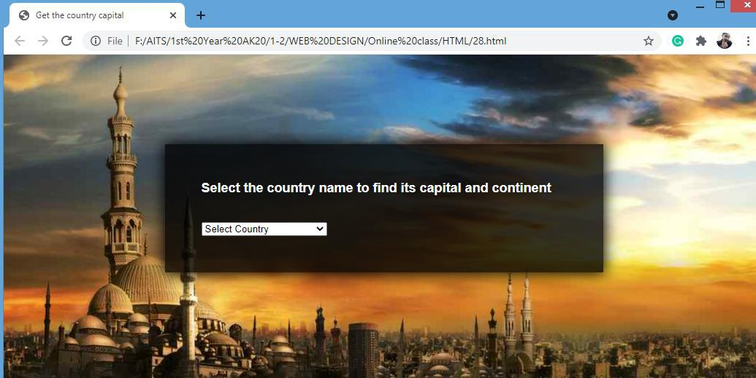**Output**

**Ex#2**

**HTML**

<!DOCTYPE html>

<html>

<head>

<style type="text/css">

body

{

background-image:url('images/cse.png');

background-repeat:no-repeat;

background-position:center center;

background-attachment:fixed;

background-color:pink;

}

a:link { text-decoration:none;color:orange; }

a:visited { text-decoration:none;color:red; }

a:hover { text-decoration:underline;color:blue; }

a:active { text-decoration:underline;color:purple; }

h3 { color:green; }

.c1{cursor:crosshair}

.c2{cursor:pointer}

.c3{cursor:move}

.c4{cursor:text}

.c5{cursor:wait}

.c6{cursor:help}

</style>

<link rel="stylesheet" type="text/css" href="style.css">

</head>

<body bgcolor="cyan">

<h1 style="color:blue;text-align:center;"> CSS (Inline, Internal and External) </h1>

<p>This Paragraph is a Not Styled</p>

<p class="left">This Paragraph is Styled by class "Left"</p>

<p class="center">This Paragraph is Styled by class "Center"</p>

<p class="right">This Paragraph is Styled by class "Right"</p>

<b>This is normal Bold</b> <br>

<b id="headline">This Bold Text is Styled </b>

<h2><b><a href=" ">This is a link</a></b></h2>

<h3 class="c1">The cursor over this element is plus sign</h3>

<h3 class="c2">The cursor over this element is a pointing hand</h3>

<h3 class="c3">The cursor over this element is a grasping hand</h3>

<h3 class="c4">The cursor over this element is a I bar</h3>

<h3 class="c5">The cursor over this element is a wait</h3>

<h3 class="c6">The cursor over this element is a question mark</h3>

</html>

**CSS**

p.left

{

text-align:left;

color:blue;

font-family:Cambria;

font-size:large;

text-indent:20px;

}

p.center

{

text-align:center;

text-decoration:underline;

text-transform:uppercase;

letter-spacing:-3px;

word-spacing:20px;

font-size:larger;

}

p.right

{

text-align:right;

color:red;

font-family:Tahoma;

font-size:15pt;

text-decoration:overline;

font-style:italic;

}

b#headline

{

color:orange;

font-size:22px;

font-family:arial;

text-decoration:underline;

}

**Output**

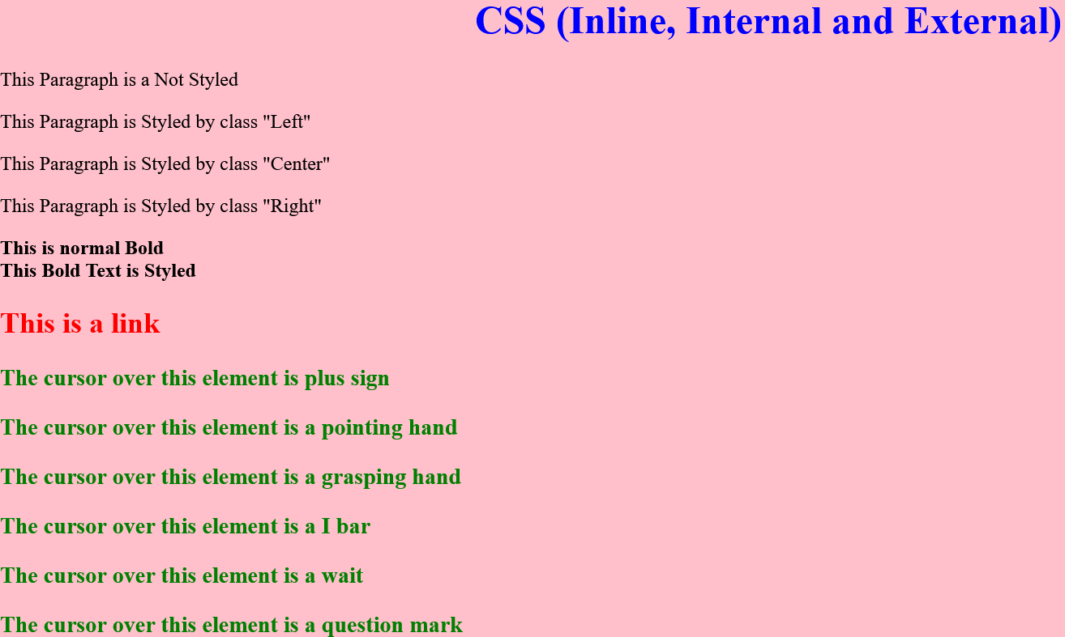

**Lab 4**

**Table**

**Ex#1**

<!DOCTYPE html>

<html>

<head>

<title>forms and and and tables</title>

</head>

<body>

<table border=”10" cellspacing=”5" cellpadding=”5" align=”center”>

<caption><h4><b><u>Sales Figures</u></b></h4></caption>

<tr><th></th><th>2019</th><th>2020</th></tr>

<tr><td>Jan</td><td>10%</td><td>12%</td></tr>

<tr><td>Feb</td><td>14%</td><td>17%</td></tr>

</table>

</body>

</html>

**Output**

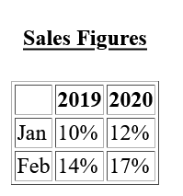

**Ex#2**

<!DOCTYPE html>

<html>

<head>

<title>forms and and and tables</title>

</head>

<body>

<table border="1" >

<tr>

<th>Name</th>

<th>Age</th>

<th>Country</th>

</tr>

<tr>

<td>Harry Depp</td>

<td>28</td>

<td>Britain</td>

</tr>

<tr>

<td>John Smith</td>

<td>35</td>

<td>USA</td>

</tr>

<tr>

<td>Ram Krishna</td>

<td>19</td>

<td>Nepal</td>

</tr>

</table>

</body>

</html>

**Output**

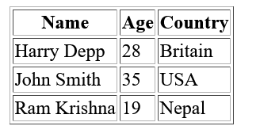

**Form**

**Ex#1**

<!DOCTYPE html>

<html>

<head>

<title>forms and and and tables</title>

</head>

<body>

<form method=”post” action=”ex10.php”>

First Name: <input type=”text” name=”fname”><br>

Last Name: <input type=”text” name=”lname”><p>

<input type=”submit” value=”Click here”>

<input type=”reset” value=”Clear All”>

</form>

</body>

</html>

**Output**

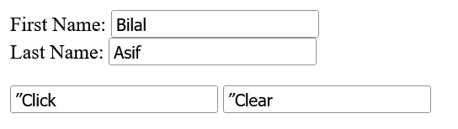

**Ex#2**

<!DOCTYPE html>

<html>

<head>

<title>forms and and and tables</title>

</head>

<body>

<form method=”post” action=”ex10.php”>

Select your Gender:<p>

<input type=”radio” name=”gender” value=”male”>Male<br>

<input type=”radio” name=”gender” value=”female”>Female</p>

<input type=”submit” value=”Click here”>

<input type=”reset” value=”Clear All”>

</form>

</body>

</html>

**Output**

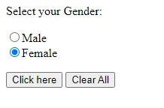

**Lab # 05**

**Ex#1**

<!DOCTYPE html>

<html>

<head>

<title>gfg</title>

<style type=text/css>

p{

background-color:rgb(255, 0, 0);

margin: 10px;

}

div

{

color: rgb(6, 240, 26);

background-color:blue;

margin: 2px;

font-size: 25px;

}

</style>

</head>

<body>

<div > div tag </div>

<div > div tag </div>

<div > div tag </div>

<div > div tag </div>

</body>

</html>

**Output**

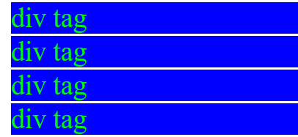

**Ex#2**

<!DOCTYPE html>

<html>

<head>

<title>gfg</title>

<style type=text/css>

p{

color: rgb(0, 0, 0);

background-color: yellow;

width: 400px;

}

h1

{

color: rgb(0, 0, 0);

background-color: goldenrod;

width: 400px;

}

h2

{

color: rgb(0, 0, 0);

background-color: red;

width: 400px;

}

</style>

</head>

<body>

<h1>GeeksforGeeks</h1>

<p>How many times were you frustrated while looking out

for a good collection of programming/algorithm/interview

questions? What did you expect and what did you get?

This portal has been created to provide well written,

well thought and well-explained solutions for selected

questions.

</p>

<h2>GeeksforGeeks</h2>

<p>GCET is an entrance test for the extensive classroom

program by GeeksforGeeks to build and enhance Data

Structures and Algorithm concepts, mentored by Sandeep

Jain (Founder & CEO, GeeksforGeeks).He has 7 years of

teaching experience and 6 years of industry experience.

</p>

</body>

</html>

**Output**

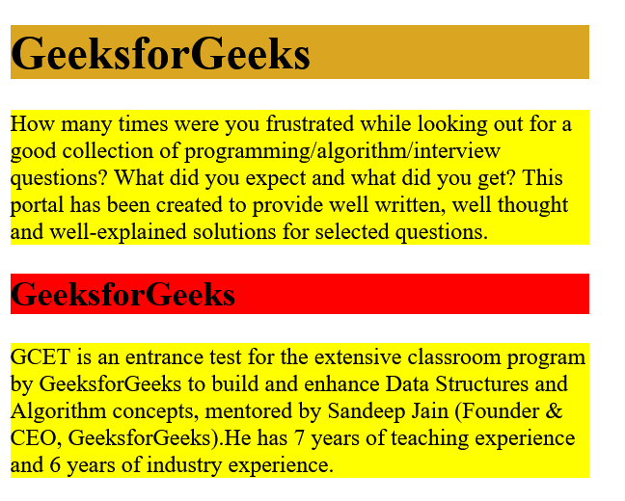

**Ex#3**

<!DOCTYPE html>

<html>

<head>

<title>gfg</title>

<style type=text/css>

.leftdiv

{

float: left;

}

.middlediv

{

float: left;

background-color:gray

}

.rightdiv

{

float: left;

}

div{

padding : 1%;

color: rgb(0, 0, 0);

background-color: whitesmoke;

width: 30%;

border: solid black;

}

</style>

</head>

<body>

<div class="leftdiv">

<h1>GeeksforGeeks</h1>

<p>How many times were you frustrated while looking out

for a good collection of programming/algorithm/interview

questions? What did you expect and what did you get?

This portal has been created to provide well written,

well thought and well-explained solutions for selected

questions.

</p>

<h2>GeeksforGeeks</h2>

<p>GCET is an entrance test for the extensive classroom

programme by GeeksforGeeks to build and enhance Data

Structures and Algorithm concepts, mentored by Sandeep

Jain (Founder & CEO, GeeksforGeeks).He has 7 years of

teaching experience and 6 years of industry experience.

</p>

</div>

<div class="middlediv">

<h1>GeeksforGeeks</h1>

<p>How many times were you frustrated while looking out

for a good collection of programming/algorithm/interview

questions? What did you expect and what did you get?

This portal has been created to provide well written,

well thought and well-explained solutions for selected

questions.

</p>

<h2>GeeksforGeeks</h2>

<p>GCET is an entrance test for the extensive classroom

programme by GeeksforGeeks to build and enhance Data

Structures and Algorithm concepts, mentored by Sandeep

Jain (Founder & CEO, GeeksforGeeks).He has 7 years of

teaching experience and 6 years of industry experience.

</p>

</div>

<div class="rightdiv">

<h1>GeeksforGeeks</h1>

<p>How many times were you frustrated while looking out

for a good collection of programming/algorithm/interview

questions? What did you expect and what did you get?

This portal has been created to provide well written,

well thought and well-explained solutions for selected

questions.

</p>

<h2>GeeksforGeeks</h2>

<p>How many times were you frustrated while looking out

for a good collection of programming/algorithm/interview

questions? What did you expect and what did you get?

This portal has been created to provide well written,

well thought and well-explained solutions for selected

questions.

</p>

</div>

</body>

</html>

**Output**

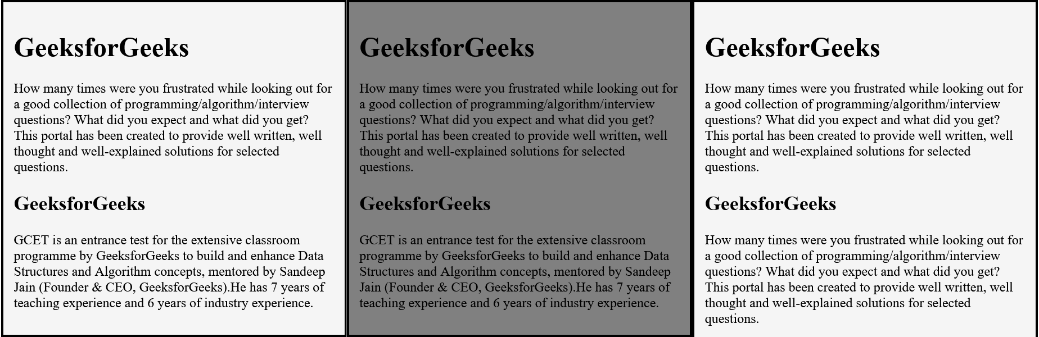

**Ex#3**

<!DOCTYPE html>

<html>

<head>

<title>gfg</title>

<style type=text/css>

p{

background-color:gray;

margin: 10px;

}

div

{

color: rgb(242, 3, 3);

background-color:aqua;

margin: 2px;

font-size: 25px;

}

span

{

color: black;

background-color: gray;

margin: 5px;

font-size: 25px;

}

</style>

</head>

<body>

<div > div tag </div>

<div > div tag </div>

<div > div tag </div>

<div > div tag </div>

<span>span-tag</span>

<span>span-tag</span>

<span>span-tag</span>

<span>span-tag</span>

</body>

</html>

**Output**

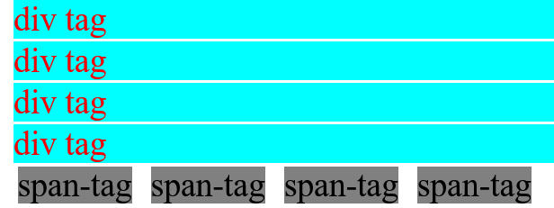

**Ex#4**

<!DOCTYPE html>

<html>

<head>

<style>

body {

background-color: rgb(26, 177, 215);

}

h1 {

color: maroon;

margin-left: 40px;

}

</style>

</head>

<body>

<h1>This is a heading</h1>

<p>This is a paragraph.</p>

</body>

</html>

**Output**

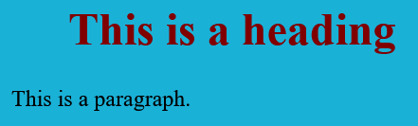

**Ex#5**

<!DOCTYPE html>

<html>

<head>

<title>Internal CSS</title>

<style>

.main {

text-align: center;

}

.GFG {

color: #009900;

font-size: 50px;

font-weight: bold;

}

.geeks {

font-style: bold;

font-size: 20px;

}

</style>

</head>

<body>

<div class="main">

<div class="GFG">GeeksForGeeks</div>

<div class="geeks">

A computer science portal for geeks

</div>

</div>

</body>

</html>

**Output**

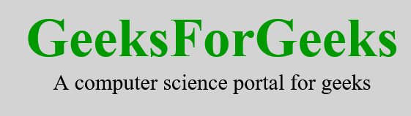

**Lab # 06**

**Ex#1**

**HTML**

<!DOCTYPE html>

<html>

<head>

<link rel="stylesheet" href="lab6.css">

</head>

<body>

<h1>This is a Heading</h1>

<p>This is a Paragraph</p>

</body>

</html>

**CSS**

body{

background-color: rgba(38, 123, 134, 0.272);

}

h1 {

color: blue;

}

p {

color: rgb(255, 0, 0);

}

**Output**

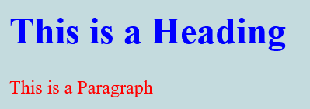

**Ex#2**

**HTML**

<!DOCTYPE html>

<html>

<head>

<link rel="stylesheet" href="lab6.css">

</head>

<body>

<h1>BILAL Asif</h1>

</body>

</html>

**CSS**

body {

background-color: rgb(113, 232, 216);

}

h1 {

color: navy;

margin-left: 30px;

}

**Output**



**Ex#3**

**HTML**

<!DOCTYPE html>

<html>

<head>

<link rel="stylesheet" type="text/css" href="lab6.css">

</head>

<body>

<h1>Welcome to Example Website</h1>

<p>This is an example paragraph.</p>

</body>

</html>

**CSS**

body {

font-family: Arial, sans-serif;

background-color: #f2f2f2;

color: #333;

}

h1 {

color: #ff0000;

text-align: center;

}

p {

font-size: 16px;}

**Output**

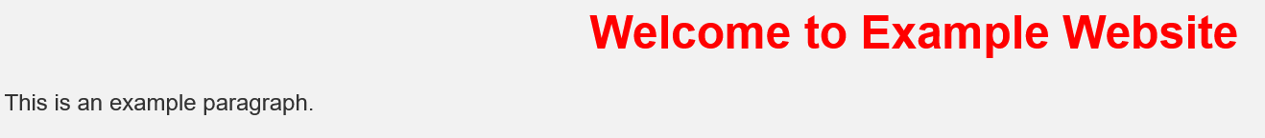

**Lab # 07**

**Ex#1**

<!DOCTYPE html>

<html>

<head>

<title>Internal CSS Example</title>

<style>

h1 {

color: rgb(255, 0, 0);

font-size: 24px;

}

</style>

</head>

<body>

<h1>This is a Heading</h1>

</body>

</html>

**Output**



**Ex#2**

<!DOCTYPE html>

<html>

<head>

<title>Internal CSS Example</title>

<style>

h1 {

color: rgb(0, 0, 0);

font-size: 24px;

}

p {

color: rgb(255, 0, 0);

font-size: 16px;

}

</style>

</head>

<body>

<h1>This is a Heading</h1>

<p>This is a paragraph.</p>

</body>

</html>

**Output**

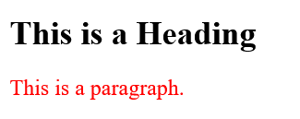

**Ex#3**

<!DOCTYPE html>

<html>

<head>

<title>Internal CSS Example</title>

<style>

.highlight {

background-color: yellow;

font-weight: bold;

}

#special {

color: red;

text-decoration: underline;

}

</style>

</head>

<body>

<h1 class="highlight">This is a Heading</h1>

<p>This is a <span id="special">special</span> paragraph.</p>

</body>

</html>

**Output**

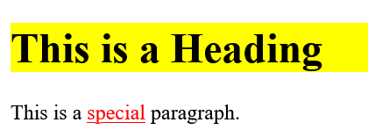

**Ex#4**

<!DOCTYPE html>

<html>

<head>

<style>

body {

background-color: linen;

}

h1 {

color: Red;

margin-left: 80px;

}

</style>

</head>

<body>

<h1>The internal style sheet is applied on this heading.</h1>

<p>This paragraph will not be affected.</p>

</body>

</html>

**Output**

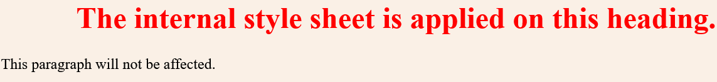

**Lab # 08**

**Ex#1**

<!DOCTYPE html>

<html>

<head>

<title>Grid Layout Example</title>

<style>

.container {

display: grid;

grid-template-columns: 1fr 1fr 1fr;

grid-gap: 10px;

}

.item {

background-color: #eaeaea;

padding: 20px;

text-align: center;

}

</style>

</head>

<body>

<div class="container">

<div class="item">Item 1</div>

<div class="item">Item 2</div>

<div class="item">Item 3</div>

</div>

</body>

</html>

**Output**



**Ex#2**

<!DOCTYPE html>

<html lang="en">

<head>

<meta charset="UTF-8" />

<meta http-equiv="X-UA-Compatible" content="IE=edge" />

<meta name="viewport" content="width=device-width, initial-scale=1.0" />

<meta property="og:title" content="Our Menu" />

<meta property="og:type" content="website" />

<meta property="og:image" content="logo.png" />

<meta property="og:url" content="https://littlelemon/" />

<meta

property="og:description"

content="Little Lemon is a family-owned Mediterranean restaurant, focused on traditional recipes served with a modern twist."

/>

<meta property="og:locale" content="en_US" />

<meta property="og:site_name" content="Little Lemon" />

<meta

name="author"

content="Little Lemon is owned by two Italian brothers, Mario and Adrian"

/>

<link rel="stylesheet" href="styles.css" />

<title>Little Lemon</title>

</head>

<body>

<header>

<img src="Asset 16@4x.png" alt="Little Lemon Logo" />

</header>

<nav class="nav" style="list-style: none">

<ul>

<li><a href="index.html">Home</a></li>

<li><a href="index.html">Menu</a></li>

<li><a href="index.html">Book</a></li>

<li><a href="index.html">About</a></li>

</ul>

</nav>

<main>

<section class="banner">

<article>

<h1 class="trans">30% Off This Weekend</h1>

</article>

</section>

<section class="parent">

<article class="card">

<h1>Our New Menu</h1>

<br /><img src="menu.jpg" alt="" class="img" />

<br />

<p>

Based in Chicago, Illinois, Little Lemon is a family-owned

Mediterranean restaurant, focused on traditional recipes served with

a modern twist. The chefs draw inspiration from Italian, Greek, and

Turkish culture and have a menu of 12-15 items that they rotate

seasonally.

</p>

</article>

<article class="card">

<h1>Book a Table</h1>

<br /><img src="reservetable.jpeg" alt="" class="img" />

<br />

<p>

Based in Chicago, Illinois, Little Lemon is a family-owned

Mediterranean restaurant, focused on traditional recipes served with

a modern twist. The chefs draw inspiration from Italian, Greek, and

Turkish culture and have a menu of 12-15 items that they rotate

seasonally.

</p>

</article>

<article class="card">

<h1>Opening Hours</h1>

<br /><img src="openinghours.jpeg" alt="" class="img" />

<br />

<p>

Based in Chicago, Illinois, Little Lemon is a family-owned

Mediterranean restaurant, focused on traditional recipes served with

a modern twist. The chefs draw inspiration from Italian, Greek, and

Turkish culture and have a menu of 12-15 items that they rotate

seasonally.

</p>

</article>

</section>

</main>

<footer>

<div class="imgcard"><img src="Asset 9@4x.png" alt="" /></div>

<div class="copyrights"><p>&copy; Copyprights Little Lemon</p></div>

</footer>

</body>

</html>

**Output**

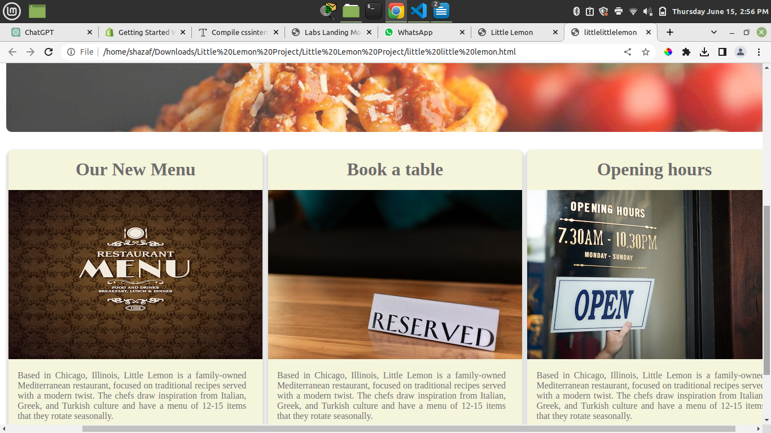

**Lab # 09**

**Ex#1**

<!DOCTYPE html>

<html>

<head>

lab9

</head>

<body>

<script>

if (condition) {

// code to execute if the condition is true

} else {

// code to execute if the condition is false

}

</script>

</body>

</html>

<!DOCTYPE html>

<html>

    <head>

        lab9

    </head>

    <body>

        <script>

            if (condition) {

  // code to execute if the condition is true

} else {

  // code to execute if the condition is false

}

        </script>

    </body>

</html>

**Ex#2**

<!DOCTYPE html>

<html>

<head>

lab9

</head>

<body>

<script>

switch (expression) {

case value1:

// code to execute if expression matches value1

break;

case value2:

// code to execute if expression matches value2

break;

default:

// code to execute if expression doesn't match any case

break;

}

</script>

</body>

</html>

<!DOCTYPE html>

<html>

    <head>

        lab9

    </head>

    <body>

        <script>

        switch (expression) {

  case value1:

    // code to execute if expression matches value1

    break;

  case value2:

    // code to execute if expression matches value2

    break;

  default:

    // code to execute if expression doesn't match any case

    break;

}

        </script>

    </body>

</html>

**Ex#3**

<!DOCTYPE html>

<html>

<head>

lab9

</head>

<body>

<script>

for (initialization; condition; increment/decrement) {

// code to be executed in each iteration

}

</script>

</body>

</html>

<!DOCTYPE html>

<html>

    <head>

        lab9

    </head>

    <body>

        <script>

       for (initialization; condition; increment/decrement) {

  // code to be executed in each iteration

}

        </script>

    </body>

</html>

**Ex#4**

<!DOCTYPE html>

<html>

<head>

lab9

</head>

<body>

<script>

while (condition) {

// code to be executed as long as the condition is true

}

</script>

</body>

</html>

<!DOCTYPE html>

<html>

    <head>

        lab9

    </head>

    <body>

        <script>

     while (condition) {

  // code to be executed as long as the condition is true

}

        </script>

    </body>

</html>

**Ex#5**

<!DOCTYPE html>

<html>

<head>

lab9

</head>

<body>

<script>

do {

// code to be executed at least once

} while (condition);

</script>

</body>

</html>

<!DOCTYPE html>

<html>

    <head>

        lab9

    </head>

    <body>

        <script>

    do {

  // code to be executed at least once

} while (condition);

        </script>

    </body>

</html>

**Ex#6**

let num = 10;

if (num > 0) {

console.log("Number is positive.");

} else if (num < 0) {

console.log("Number is negative.");

} else {

console.log("Number is zero.");

}

**Output**



**Ex#7**

let day = "Monday";

switch (day) {

case "Monday":

console.log("It's the beginning of the week.");

break;

case "Friday":

console.log("It's the end of the week.");

break;

default:

console.log("It's another day of the week.");

break;

}

**Output**

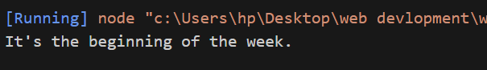

**Ex#8**

for (let i = 0; i < 5; i++) {

console.log("Iteration:", i);

}

**Output**

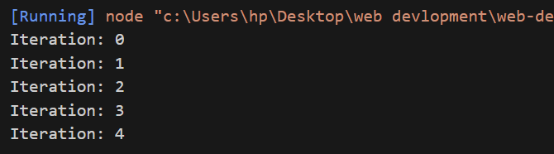

**Ex#9**

let count = 0;

while (count < 5) {

console.log("Count:", count);

count++;

}

**Output**

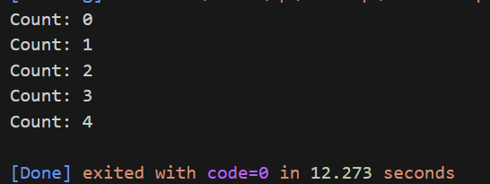

**Ex#10**

let x = 0;

do {

console.log("Value of x:", x);

x++;

} while (x < 3);

**Output**

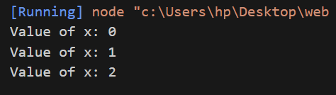

**Lab # 10**

**Ex#1**

let person = {

name: "John",

age: 30,

profession: "Web Developer"

};

console.log(person.name);

console.log(person.age);

console.log(person.profession);

public class Main {

int x = 5;

public static void main(String[] args) {

Main myObj = new Main();

System.out.println(myObj.x);

}

}

**Output**

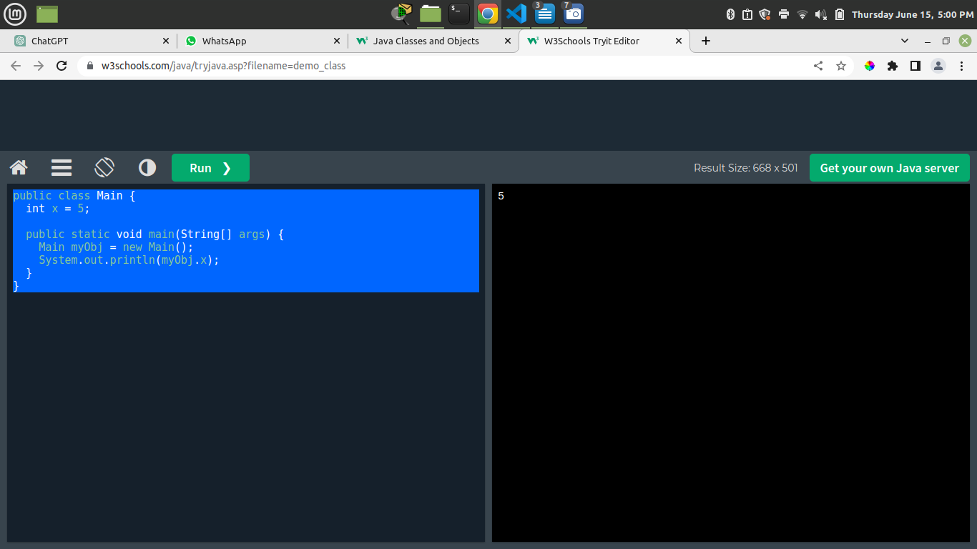

**Ex#2**

let person = {

name: "John",

age: 30,

profession: "Web Developer",

sayHello: function() {

console.log("Hello, my name is " + this.name);

}

};

person.sayHello();

**Output**

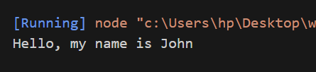

**Ex#3**

class Person {

constructor(name, age, profession) {

this.name = name;

this.age = age;

this.profession = profession;

}

sayHello() {

console.log("Hello, my name is " + this.name);

}

}

let person1 = new Person("John", 30, "Web Developer");

let person2 = new Person("Jane", 25, "Designer");

person1.sayHello();

person2.sayHello();

**Output**

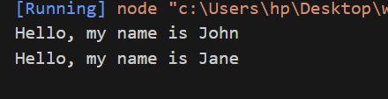

**Ex#4**

class Shape {

constructor(color) {

this.color = color;

}

draw() {

console.log("Drawing a shape.");

}

}

class Circle extends Shape {

constructor(color, radius) {

super(color);

this.radius = radius;

}

draw() {

console.log("Drawing a circle with radius " + this.radius);

}

}

let circle = new Circle("red", 5);

circle.draw();

**Output**

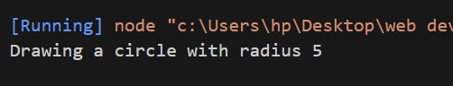

**Lab # 11**

**Ex#1**

let fruits = ["apple", "banana", "orange"];

console.log(fruits[0]);

fruits.push("grape");

console.log(fruits);

fruits.pop();

console.log(fruits);

**Output**

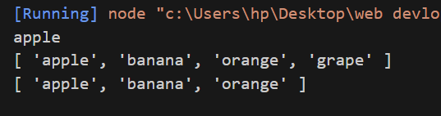

**Ex#2**

let person = {

name: "John",

age: 30,

profession: "Web Developer",

sayHello: function() {

console.log("Hello, my name is " + this.name);

}

};

console.log(person.name);

person.sayHello();

person.location = "New York";

console.log(person);

delete person.age;

console.log(person);

**Output**

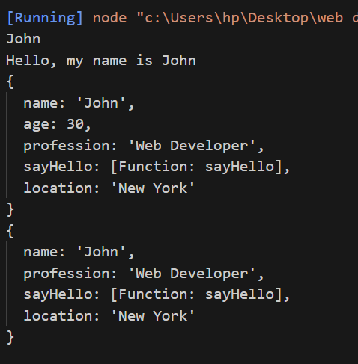

**Ex#3**

function addNumbers(num1, num2) {

return num1 + num2;

}

let sum = addNumbers(5, 10);

console.log(sum);

**Output**

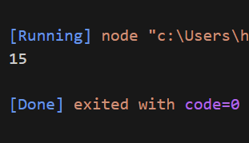

**Ex#4**

<!DOCTYPE html>

<html>

<body>

<h1>JavaScript Arrays</h1>

<h2>The join() Method</h2>

<p>The join() method joins array elements into a string.</p>

<p>It this example we have used " * " as a separator between the elements:</p>

<p id="demo"></p>

<script>

const fruits = ["Banana", "Orange", "Apple", "Mango"];

document.getElementById("demo").innerHTML = fruits.join(" * ");

</script>

</body>

</html>

**Output**

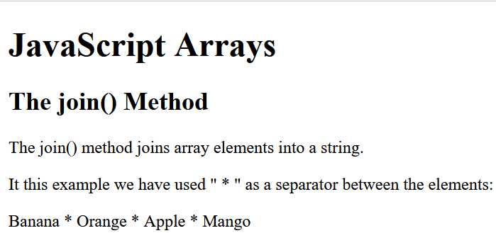

**Ex#5**

<!DOCTYPE html>

<html>

<body>

<h2>JavaScript Objects</h2>

<p>Creating an object:</p>

<p id="demo"></p>

<script>

let person = {

firstName : "John",

lastName : "Doe",

age : 50,

eyeColor : "blue"

};

document.getElementById("demo").innerHTML = person.firstName + " " + person.lastName;

</script>

</body>

</html>

**Output**

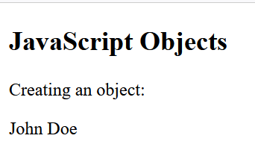

**Lab # 12**

**Ex#1**

try {

// Syntax error - missing closing parenthesis

console.log("Hello, World";

} catch (error) {

console.log("Syntax error occurred:", error.message);

}

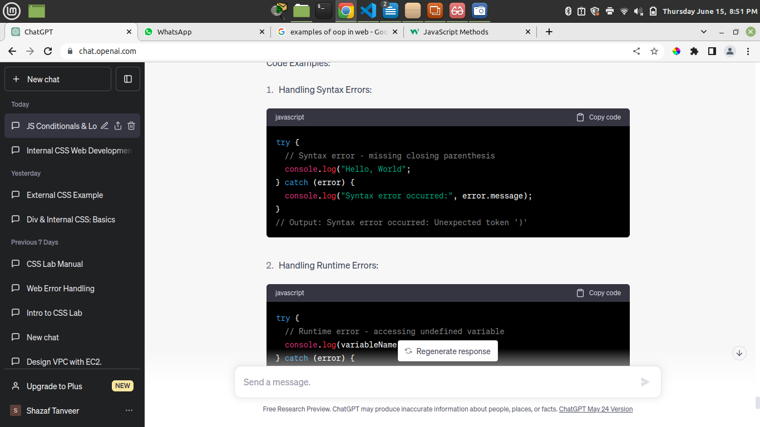**Output**

**Ex#2**

try {

console.log(variableName);

} catch (error) {

console.log("Runtime error occurred:", error.message);

}

**Output**

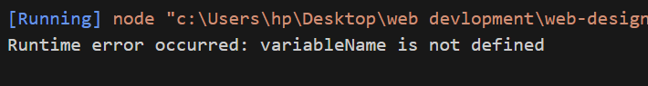

**Ex#3**

try {

let num1 = 10;

let num2 = 0;

if (num2 === 0) {

throw new Error("Division by zero error");

}

let result = num1 / num2;

console.log("Result:", result);

} catch (error) {

console.log("Logical error occurred:", error.message);

}

**Output**

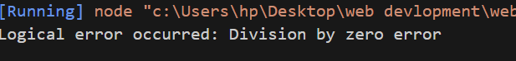

**Lab # 13**

**Ex#1**

function square(x) {

return x * x;

}

console.log(square(3));

console.log(square(4));

**Output**

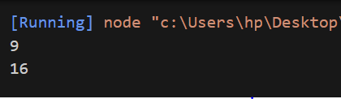

**Ex#2**

let numbers = [1, 2, 3, 4, 5];

let doubledNumbers = numbers.map(function(num) {

return num * 2;

});

console.log(numbers);

console.log(doubledNumbers);

**Output**

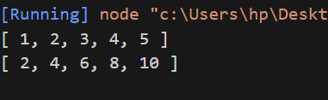

**Ex#3**

function doOperation(x, y, operation) {

return operation(x, y);

}

function add(x, y) {

return x + y;

}

function multiply(x, y) {

return x * y;

}

console.log(doOperation(3, 4, add));

console.log

(doOperation(3, 4, multiply));

**Output**

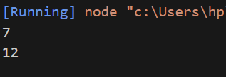

**Ex#4**

function square(x) {

return x * x;

}

function addTwo(x) {

return x + 2;

}

let squareAndAddTwo = function(x) {

return addTwo(square(x));

};

console.log(squareAndAddTwo(3));

**Output**

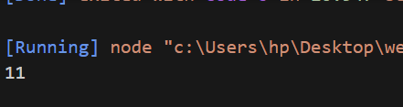

**Lab # 14**

Example 1:

1. function showName()
2. let name - "GeeksforGeeks";
3. showname()
4. console.log(name);

Output:

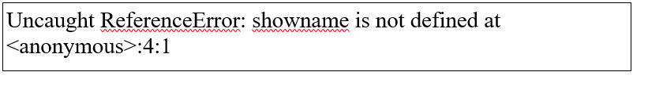

Example 2:

function showName

let name = "GeeksforGeeks";

console.log(name);

showName();

Output:



Example 3:

function fun() {

    let a = 10;

    console.log(a);

}

console.log(a);

Output:

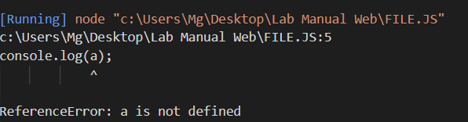

Example 4:

let a = 10;

function fun() {

    let a = 20;

    console.log(a);

}

console.log(a);

Output:

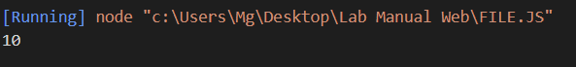

Example 1:

let paintColor = 'red'

const paint = (() => {

    return {

        changeColorToBlue: () => {

            paintcolor: 'Blue';

             return paintColor;

        },

        changeColorToGreen: () => {

            paintColor: 'Green';

            return paintColor;

        }

    }

})();

console .log(

    paint.changeColorToBlue()

)

Output:

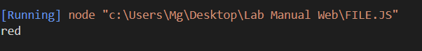

### 3. Hoisting

Example 1:

function cowSays(sound) {

    console.log(sound);

}

cowSays('moo');

Output:

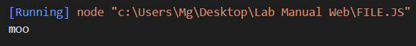

Example 2:

let a = 5;

console.log(a);

Output:



Output

a = 5;

console.log(a);

let a;

Output

### 4. Closures

Example 1:

const first = () => {

    const greet = 'Hi';

    const second = () => {

        const name = 'john';

        console.log(greet);

    }

    return second;

}

const newFunc = first();

newFunc();

Output:

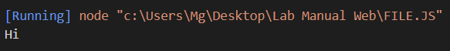

### 5. Callbacks

Example 1:

Const greeting = (name) => {

    console.log('Hello' + name);

}

const processUserName = (callback) => {

    name = 'GeeksforGeeks';

    callback(name);

}

processUserName(greeting);

Output:

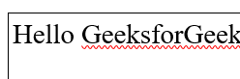

### 6. Promises

Example 1:

const promise = new Promise((resolve, reject) => {

    isNameExist = true;

    if (isNameExist) {

        resolve("User name exist")

    } else {

        reject("error")

    }

})

promise.then(result => console.log(result)).catch(() => {

            console.log('error!')

            })

Output:

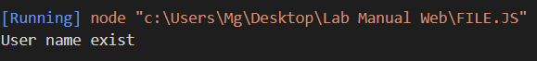

### **7. Async & Await**

Example 1:

const showPosts = async () => {

    try {

        const response = await fetch('https://jsonplaceholder.typicode.com/posts');

        const posts = await response.json();

        console.log(posts);

    } catch (error) {

        console.error('Error fetching posts:', error);

    }

}

showPosts();

Output:

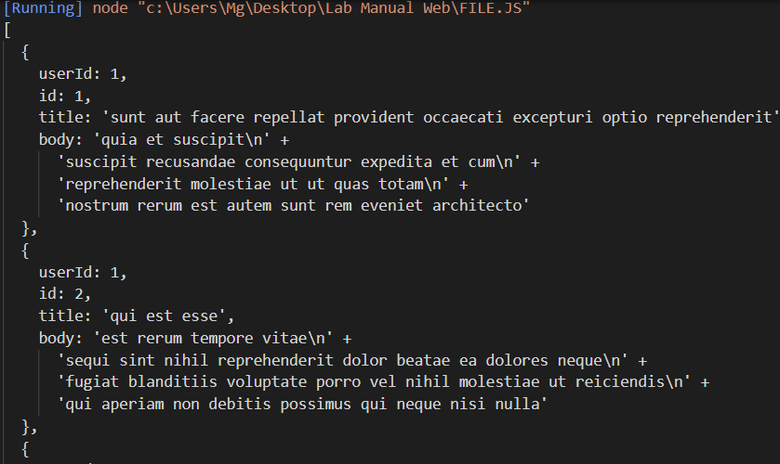

**LAB 16**

1. **Unit Testing with Jest:**

Example 1:

function sum(a, b) {

    return a + b;

  }

  // Test case using Jest

  let test('Adds two numbers correctly', () => {

    expect(sum(2, 3)).toBe(5);

    expect(sum(0, 0)).toBe(0);

    expect(sum(-5, 5)).toBe(0);

  });

Output:

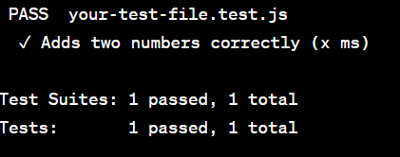

**2. Integration Testing with Mocha and Chai:**

Example 1:

class Calculator {

    add(a, b) {

      return a + b;

    }

    subtract(a, b) {

      return a - b;

    }

  }

  module.exports = Calculator;

  // test-calculator.js

  const assert = require('chai').assert;

  const Calculator = require('./calculator'); // Assuming your Calculator class is in the same directory

  describe('Calculator', () => {

    let calculator;

    beforeEach(() => {

      calculator = new Calculator();

    });

    it('should add two numbers correctly', () => {

      assert.equal(calculator.add(2, 3), 5);

      assert.equal(calculator.add(-5, 5), 0);

    });

    it('should subtract two numbers correctly', () => {

      assert.equal(calculator.subtract(5, 3), 2);

      assert.equal(calculator.subtract(10, 5), 5);

    });

  });

Output:

